**Name:** IZERE IRASUBIZA Eric

**Reg Number:** 221018630

**CLASS NO:** 13

**PROJECT NAME: ATM System**

**JAVA PROJECT ASSIGNMENT**

**Planning**

Our system will help bank user to withdraw money from bank with only bank card linked with his bank account and using pin to enter in your account. This system will help user to make payment quickly and our system has no border for accessing. All our planning is to make the best to our clients such as faster payment, access money easily, saving time, etc.

**Design**

We want to access user information found in bank database then connect it with our system after that all information of user needed to access this money already will be accessible in our system then user are able to login on our system by entering bank card on our device then user insert his pin to login, exactly user is able to withdraw

**Development**

In development phase we used java language and MySQL database. We used java NetBeans program as our compiler and also help us to make the interface design much easier, while trying to connect to the database we used MySQL connector to allow us access to our MySQL database then we used SQL language to interact with the database

**Testing**

**Login Home**

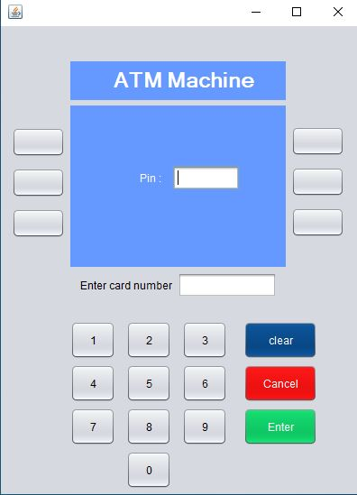 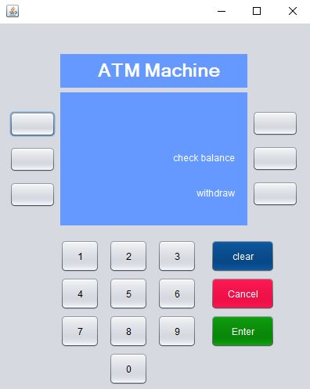

**Check balance Withdraw**

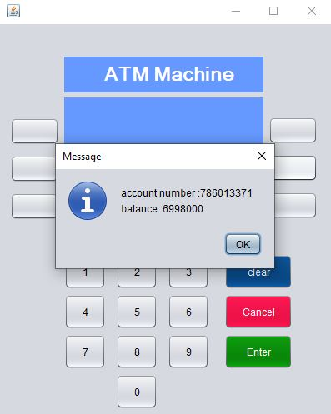 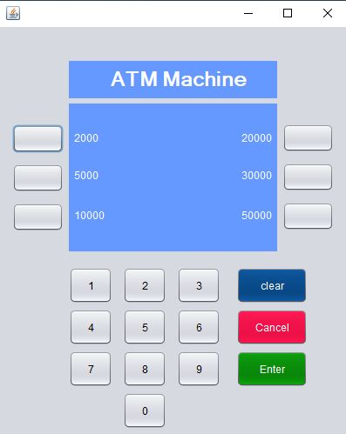

**Deployment**

Within the deployment faze we will have to first connect our system to the bank users database with this the app will have the database in which users will find their info to log into the system. After connecting we test security and then share with user through their Smartphones.